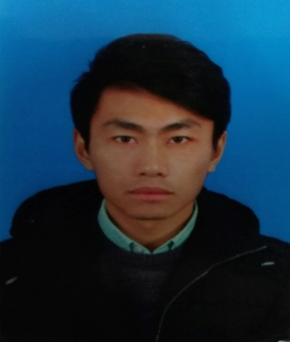**Xu Ma** born in 1993. Master student in College of Information Science & Technology, Nanjing Forestry University, Jiangsu, China. His main research interests include pattern recognition, machine learning, data mining and image processing.

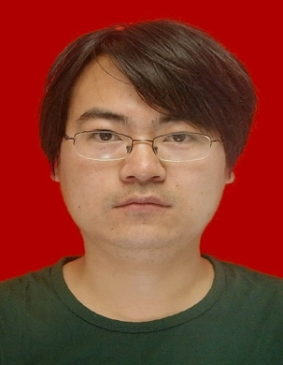**Qiaolin Ye** received the BS degree in Computer Science from Nanjing Institute of Technology, Nanjing, China, in 2007, the MS degree in Computer Science and Technology from Nanjing Forestry University, Jiangsu, China, in 2009, and the Ph.D. degree in pattern recognition and intelligence system from Nanjing University of Science and Technology, Jiangsu, China, in 2013. He is currently an associate professor with the computer science department at the Nanjing Forestry University, Nanjing, China. He has authored more than 50 scientific papers. Some of them are published in IEEE TNNLS, IEEE TIFS, and IEEE TCSVT. His research interests include machine learning, data mining, and pattern recognition.

**Shangbing Gao** received the BS degree in mathematics from the Northwestern Polytechnical University in 2003. He received the MS degree in applied mathematics from the Nanjing University of Information Science and Technology in 2006. He is now working at Huaiyin Institute of Technology as an assistant lecturer. He is currently pursuing the Ph.D. degree with School of Computer Science and Technology, Nanjing University of Science and Technology (NUST). He is on the subject of pattern recognition and intelligence systems. His current research interests include pattern recognition and computer vision.

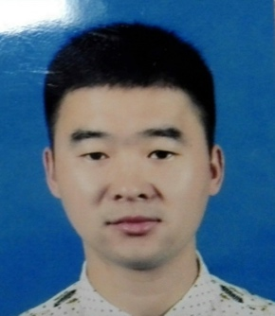**He Yan** born in 1988. Ph.D student in School of Computer Science and Engineering, Nanjing University of Science and Technology, Jiangsu, China. His main research interests include pattern recognition, machine learning and data mining.